Schedule Job for builds in Jenkins

- Login to Jenkins successfully.
Credential : admin/Passw0rd
- Now click to Jenkins available at top left panel (Marked red in below snapshot) and then click on required item ( Example : Check the status of given file in Activity Management Page)
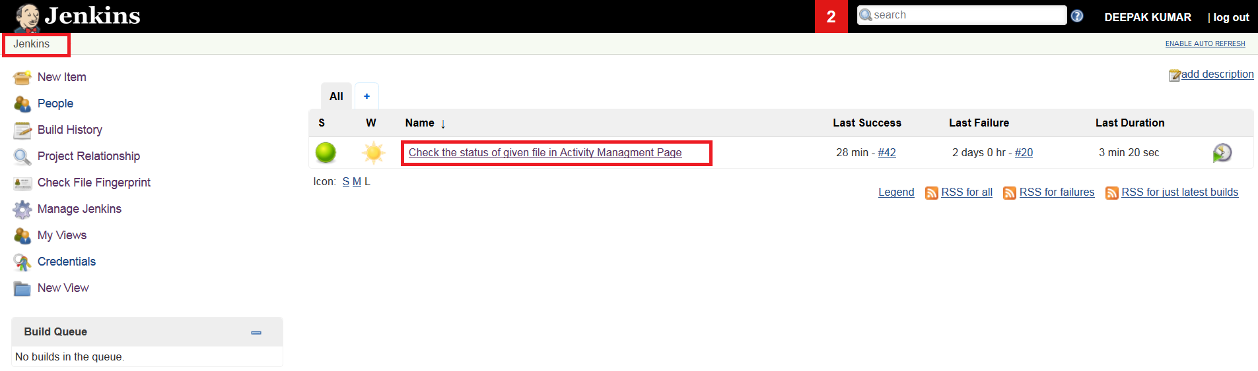
- Click on configure from left menu.
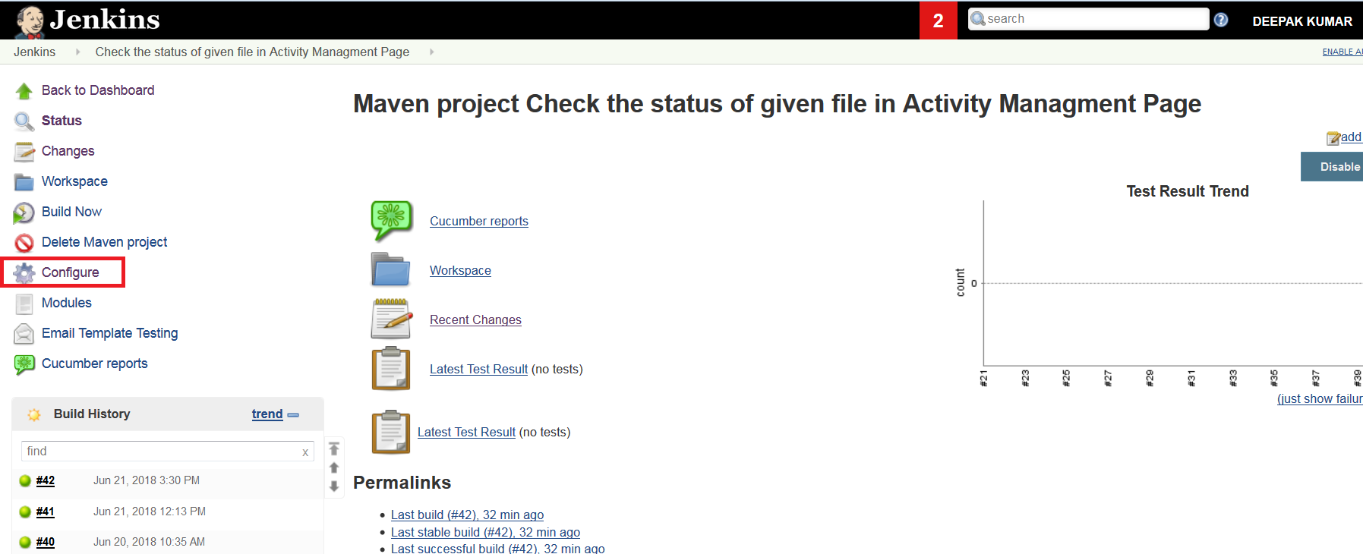
- Click on “Build Triggers” and then select the “ Build periodically”. Enter schedule as per cron syntax. ( Example : 45 12 * * 1-5 )
45 12 * * 1-5 means 12.45PM Mon to Friday.

# ┌───────────── minute (0 - 59)
# │ ┌───────────── hour (0 - 23)
# │ │ ┌───────────── day of month (1 - 31)
# │ │ │ ┌───────────── month (1 - 12)
# │ │ │ │ ┌───────────── day of week (0 - 6) (Sunday to Saturday;
# │ │ │ │ │ 7 is also Sunday on some systems)
# │ │ │ │ │
# │ │ │ │ │
# * * * * * command to execute

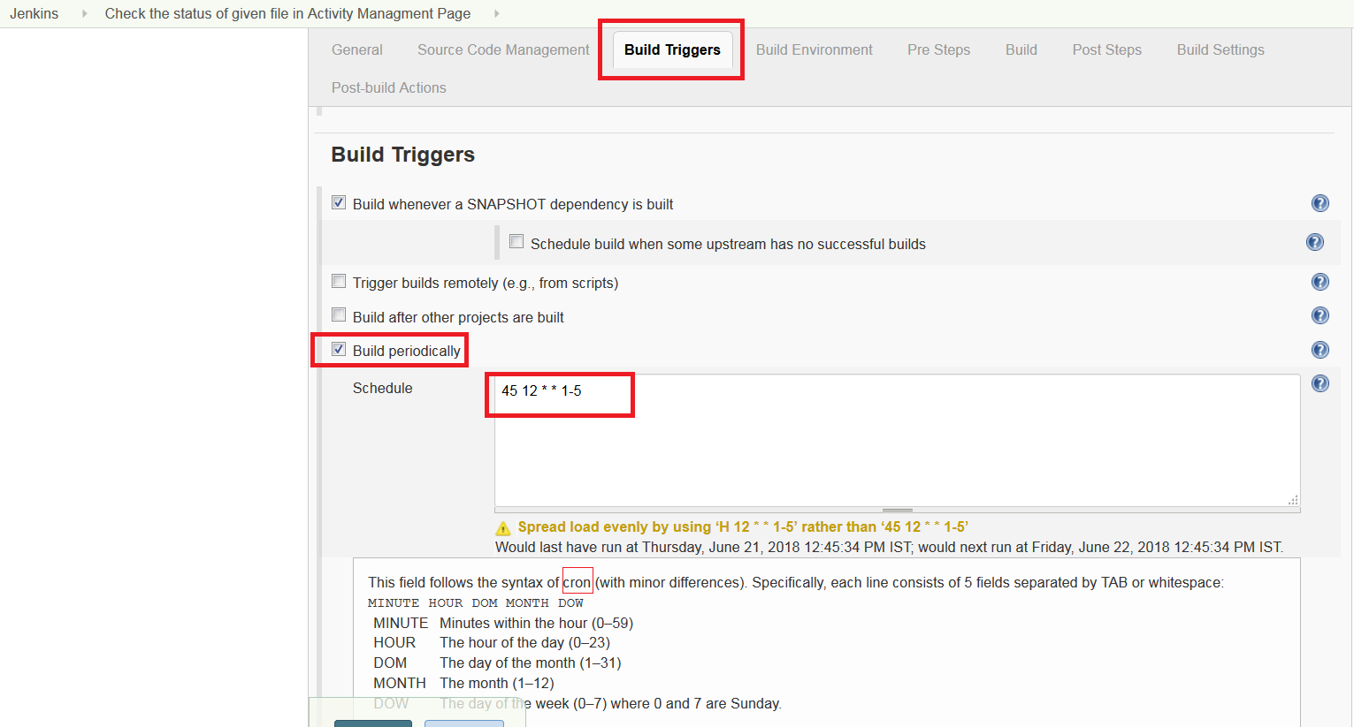
- Click Apply and then Save.

